Reducing Customer Churn for TruSource
Executive Summary
Dafne Robles
Sheikh Tijan Kuta
Leo Brewer
Ashton Mallory

- Business problem
  - The core business problem we are trying to solve is customer churn. In other words, we are trying to predict which customers will leave. Ideally, we are trying to retain the potential customers we have to maximize profitability. It is important to keep current customers because it is often more profitable than recruiting new customers. Retaining as many customers as possible and reducing customer churn is important for subscription businesses and their profitability. By building a model that predicts customer churn, we can detect signs of churning and provide TruSource with actionable insights.
- EDA and Quality Assessment
  - Before going any further, our first initiative was to gain a better understanding of our data and identify our response variable. A general overview of the data showed us a total of 5636 observations with 33 predictor variables. While we have a mix of both continuous and categorical variables, the majority of our predictor variables are categorical, including our response variable. Overall, we are solving a supervised learning classification problem.
  - Our response variable is whether or not the customer churned. This was in our data set as a column labeled “left_flag” with options of “Y” for Yes and “N” for no. In our retention data, customers who did not churn outweigh customers who did churn significantly. This will be important to know when training our model. We need to ensure that the training and testing sets contain a proportional number of customers who did and did not churn. Below is a graph showing the overall distribution of customer churn responses. 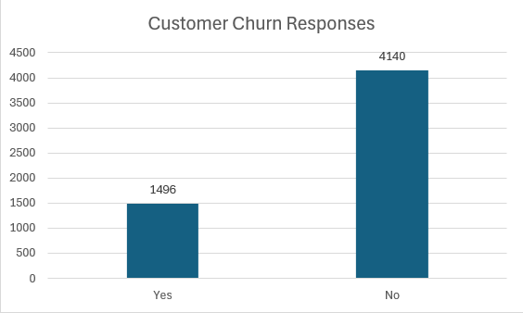
  - During the data quality assessment phase, we checked our data for missing values, NULL values, and outliers. We did not find any missing values, but did find Null values within our data. The columns with null values were the recent_offer, internet_tech and total_billed columns. The recent offers column reflects the most recent marketing offer accepted by the customer. Therefore, it makes sense that we would see null values where it is the case that a customer has not accepted any marketing offers. The internet technology also contains null values, but this is not concerning because if customers do not have DSL, fiber or cable NA is put in this column. Therefore, we can conclude that missing values will not be a problem in this data set. After viewing the summary statistics for our data set, we found no outliers or inconsistencies that would be cause for concern. Our null values will be considered later in preprocessing, so that our data can be accurately modeled.
- Pre-Processing and Feature engineering
  - After our initial data exploration, we moved on to preprocessing and first decided to handle the null values within the recent_offer, internet_tech and total_billed columns. Because of the differing nature of these columns, null values had to be handled differently for each. Below we will go over the assumptions made and steps taken to fill in missing values and prepare our data for modeling.
    - Recent_offer: The recent_offer column reflects what recent marketing offer the customer received such as Offer A, B, C, D or E. If the recent_offer column was null, it most likely means that the customer had not received any marketing offer. Because of this, we elected to fill all NA values in the recent_offer column with a value of “None”. This reflects that when that column is null, the customer has not received any marketing offer. By giving these records a value, it allows us to use this field for computation and comparison of who did and did not receive an offer.
    - Internet_tech: The internet_tech column reflects the type of internet the customer has with options of DSL, fiber-optic or cable. While most customers have internet services, some do not. These customers, for example, might just have a home-phone service, but no internet. Considering this, we have opted to replace all null values in the internet_tech column with the value “No internet”. With this field now having no missing values, it will be easier to build our model correctly.
    - Total_billed: Deciding how to appropriately handle NA values in the total_billed column was more challenging than the other missing values. These customers had 0 tenure months and no left_flag, implying that they were brand new customers who had not yet paid their first bill and had not churned. We first considered dropping the records with null values but then decided that they represent an important section of our data. If we had chosen to drop these records, we would be missing out on a key indicator for our data: new customers who have not paid a bill yet do not churn. This makes sense to us logically but including it when building the model will help our model come to this conclusion as well. Because of these factors, we chose to fill in the NA values in total_billed with 0.
  - Next it was important to create new, informative, and creative features that we considered important in our data. Below are our new columns we chose to include in our data set and our justification for including them
    - >_3_referrals: Our first feature engineering variable was a variable to show when a customer had referred 3 or more people to the business. We found this to be valuable because we wanted to examine if customers are more likely to stay with the company if they have referred at least 3 friends. With this insight, we can construct actionable insights based on referral count. In our initial data analysis, we found that if customers in our data set have 3 or more referrals, they churn only 9.8% of the time.
    - Married_with_dependents: Another feature we chose to add was a flag for customers who are married with dependents. Our initial analysis showed that customers who are married with dependents churn far less than the average customer. Only 4.38% falling into this population churn in our current data set. This is valuable information to our model.
    - Number of services: There are a few options of services that a customer can choose, and they are in separate columns with a yes or no option for each: home_phone, stream_movies, stream_music, multi_line and stream_tv. In this case we will be using number of services as a total as we don’t think there is a value in having each individual service accounted and what we think its more impactful is the number of services the customer is using.
    - Number_of_addons: we applied the same logic as above to make a column representing the number of add ons. Customers have the option to add on security, protection, and backup. We combined these measures into a count of how many additional add ons the customer chose.
    - Techincal_support: In the file we have 2 columns tech_support_std and premium_support, from the dictionary we see that both are related to whether the customer has a standard tech support or a premium and if both are no then we understand it means that they do not have any kind of technical support. We will convert this as a column that is called support: Premium, Standard or None.
- Model Choice, Mechanics and evaluation
  - To ensure our data accurately predicts new data, we chose to use train/test split. With our given data, we used 70% as the training data, leaving 30% to be the test data. This ensures that once our data is trained, we are able to test how well it performs on unseen data. This tactic also helps us avoid overfitting. If the model was trained and then tested on the same data, we would have a very high accuracy rate, but the model would not perform well on new, unseen data.
  - After testing multiple models including logistic regression and random forest, we ultimately decided on the XGBoost model as our choice for modeling our data based on it having the best performance on terms of ROC-AUC which was 0.8937.

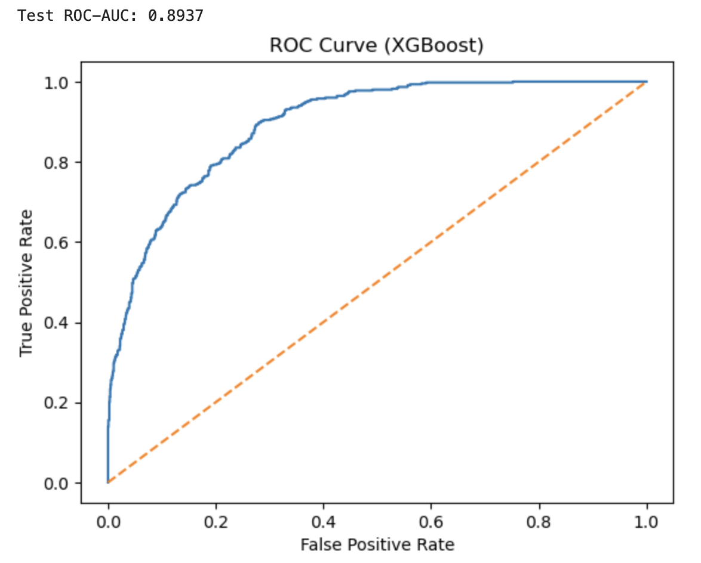

XGBoost uses gradient boosting to slowly improve predictions and usually leads to a higher accuracy in predicting data with the ultimate goal of reduced variance. XGBoost also includes many different tuning parameters, allowing you to fine tune your parameters to get the best result, including the model__scale_pos_weight parameter that can be used in cases where the data is imbalanced, which is also a reason why we chose XGBoost as our data is tending to the No for customer churn.
  - To choose our tuning parameters, we used a hyperparameter grid and slowly made changes to optimize our outcome. A hyperparameter grid automates parameter tuning, testing all combinations of parameters listed in the grid to discover what leads to optimal performance. Most parameters were handled to improve processing speed vs ROC-AUC result, except for the scale_pos_weight parameter which was calculated using the Y_train data and dividing (n negatives/ n positives).

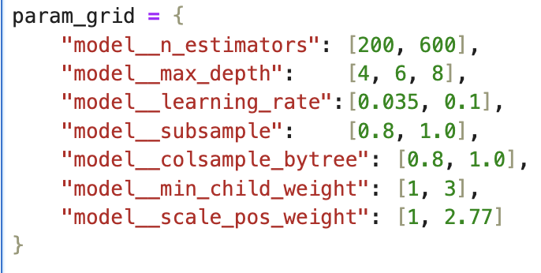
- Key performance indicators

To better understand our results, we will analyze our features in 2 ways: using the following feature importance graph from the XGBoost model and using a SHAP plot.
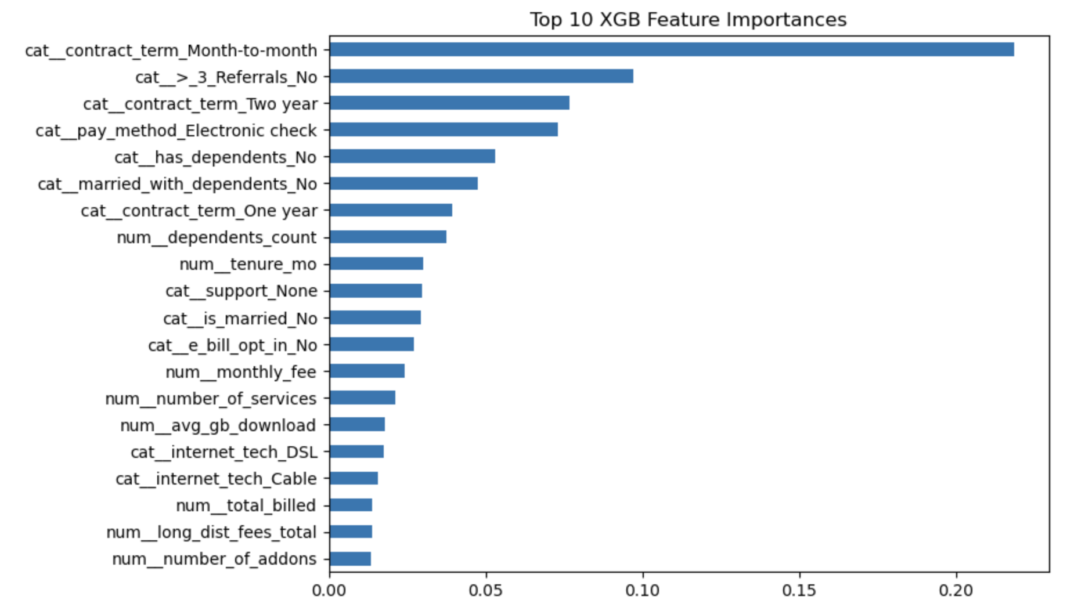
SHAP plot
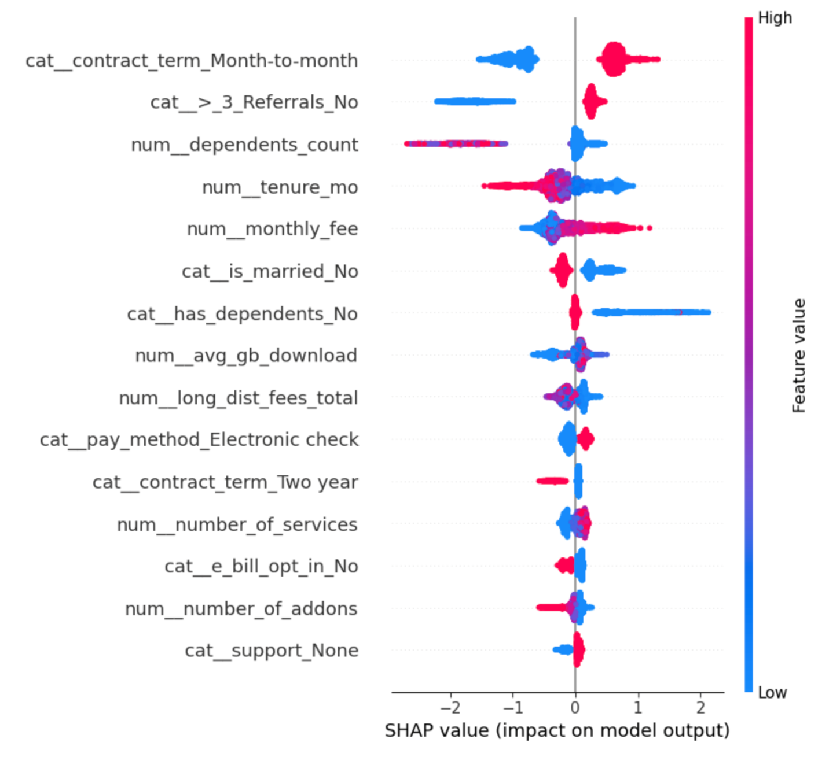
As we can observe in both plots we can see the higher ranking features that affect customer churn in this population. From both plots we can come to the next conclusions:
- Customers on the month-to-month contract are much more likely to churn in comparison to customers that are on long term contracts (1 or 2 year commitments)
- Lack of referrals is likely a consequence of a customer not being engaged with the service but it is a very good indication of customers that will likely churn.
- The first months of a customer using the service are very important and can be considered a danger zone where an action to avoid churn must be taken.
- High monthly fees can push a customer to churn if they don’t see value in the service/services.
- Customers that are not married and that have no dependents are more likely to churn
- Higher usage (specifically in gb_download) and higher number of services and/or add on reduce churn
- Customers using electronic check as a payment are more likely to churn

- Segmentation and business recommendations
Going into a deeper analysis on our data we find out that out of 1496 records of churned customers, 94% do not have dependents. Making the has dependents flag a primary marker over a customer that will churn.
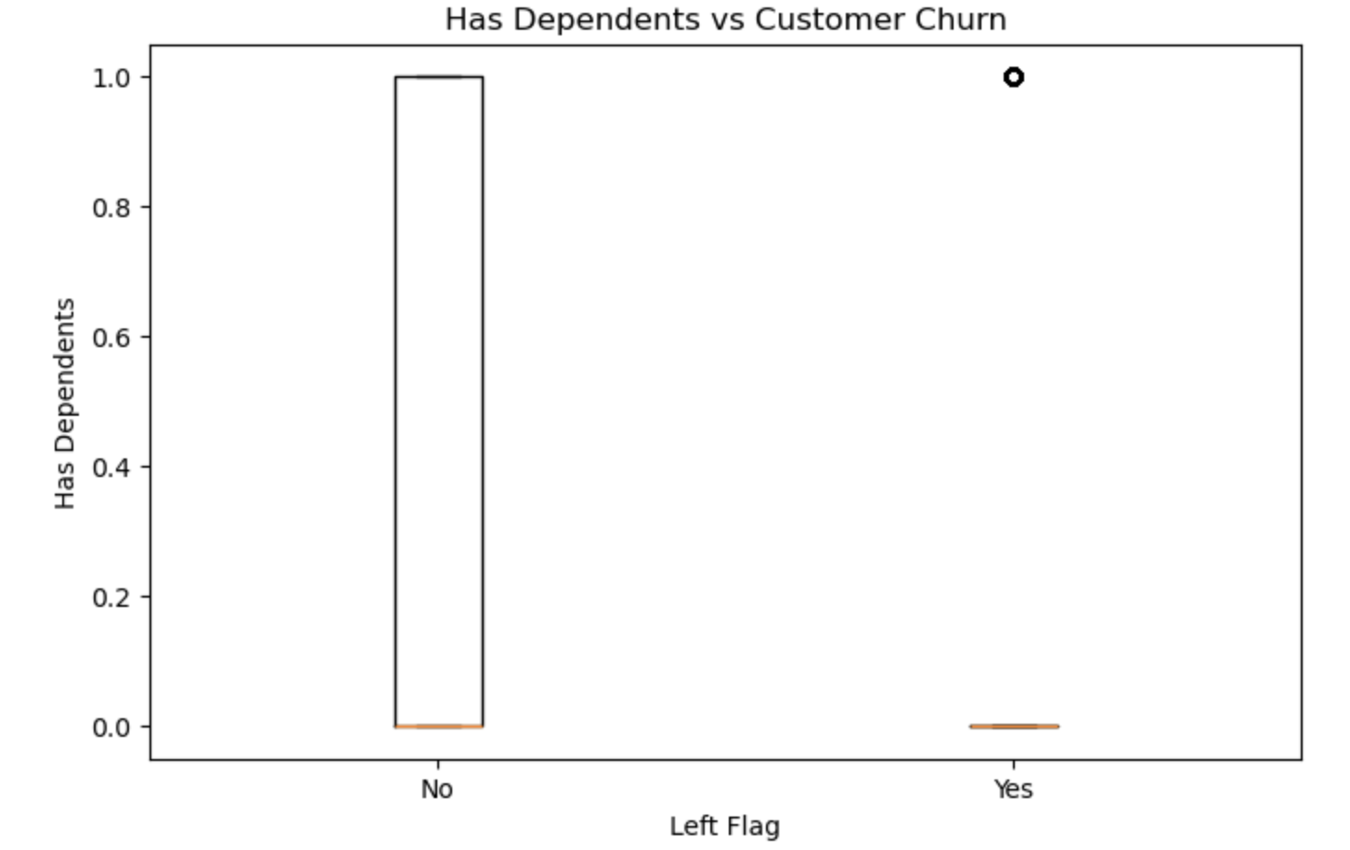

While trying to further understand the churned population we mapped out the services an individual can acquire and if a certain combination would help us understand what these customers are looking for we concluded hat there are 2 stories that are summarize our churned customers:

- Individuals that use the basic services: internet and home (either one line or multi-line) and internet
- Individuals that go all the way and use all 6 or 5 services

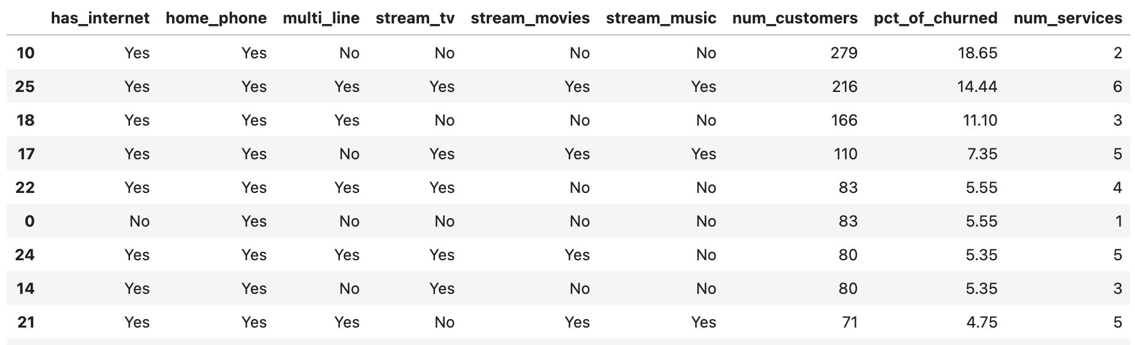

Considering these insights and the results from our XGBoost model and SHAP plot analysis we recommend the following actions:

- Prioritize early-tenure customers without dependents, as the first months represent a critical intervention window for churn prevention
- Deploy targeted retention save offers, with a focus on:
- Incentives to migrate to longer-term contracts
- Bundled service, add-on, and support packages that increase engagement
- Incentives we recommend:
- Monthly bill discount for the first 6-12 months
- Rate lock for 12 months
- One time bill credit when they sign for 12 months or more
- Penalty-free cancellation within first 60–90 days
- Downgrade options for the long-term contracts
- Reward system for referrals
- Look into the payment process using electronic checks to find feedback on how it can be improved
By reducing perceived commitment risk and enhancing the value of bundled services, these actions are intended to strengthen engagement and improve retention within this customer segment.
Tradeoffs and costs
- The tradeoff of implementing any incentive plan will be the cost. Offering customers discounts and bill credits will inevitably lead to a slight drop in revenue initially. The positive side of this is that incentive plans such as the ones listed above lead to happy customers that are more likely to stay with the company, leading to higher revenue overall.
- Enacting a reward system for referrals can also lead to some downsides. When customers are offered rewards for referring friends, it can lead to them referring simply because of the reward and not because they genuinely recommend the service. Although this will be true for some referrals, overall, a referral reward system will make customers happier, leading to more customer retention over time.

